Automatic Chuck Capping Machine YMXD
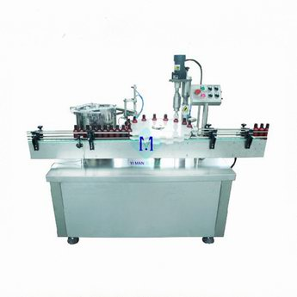
The Automatic Chuck Capping Machine allows for continuous capping of containers using one or multiple chuck heads. It’s widely used in capping of plastic/metal caps, feeds bottle, places and torques caps automatically. A cap sorting bowl and chute automatically deliver the caps to the containers and star wheel indexing is utilized to move cappers through the capping process.
Options:
- Cap sorting elevator/cap sorting bowl
- Vacuum/nitrogen filler
- Safety shields with interlock access door
Key Features:
- PLC controls, no bottle no running.
- No tools needed for changeovers for star wheels and other change parts.
- Speed adjustable, integrates with other machines.
- Adjustable torque lossless magnetic force slipping chuck head, no damage to bottle and cap.
- Complies with GMP requirements.
Technical Parameters:
- Capacity: 40-60pcs/min 60-100pcs/min 100-200pcs/min
- Power supply: 220V/380V 50/60Hz
- Power: 1.2kw
- Net weight: 600kg
- Dimension: 2400×1000×1700mm

