

***DZ-400/2E Single Chamber Vacuum Packing Machine***

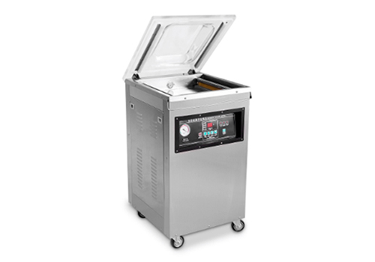

DZ400/2E Table type vacuum packing machine is featured by processing of vacuuming, sealing, cooling, which is used in vacuum packaging for the food, pharmaceutical, aquatic, chemical and electronic industries. It can prevent the products from oxidization and mildew, as well as corrosion and moisture, keeping the quality and freshness of the product over a prolonged storage time.

**PARAMETER DATA**

|  |  |
| --- | --- |
| **Model** | **DZ-400/2E** |
| Voltage | AC220/50HZ, 110V/60HZ |
| Motor Power | 1000W |
| Sealing Power | 500W |
| Ultimate Vacuum Pressure | 1 KPA |
| No.of Sealing Bars for Each Chamber | 2 pcs |
| Chamber Dimension (LxWxH)(mm) | 435*420*75mm |
| Sealing Length (mm) | 400 |
| Sealing Width (mm) | 10 |
| Vacuum Pump Rate (m³/h) | 20 |
| Material for Vacuum Chamber | Stainless steel |
| Dimension (LxWxH)(mm) | 540*490*950 |
| Net Weight (kg) | 62 |
| Distance from sealing bar to chamber side (mm) | 370 |